Ant Core
Companion Guide
Overview, setup, safety model, feature walkthrough, screenshots, and validation tools for the Seeed XIAO ESP32-S3 Sense antweight robot controller.
Source | README.md
Preset | compact_reference_guide
Target | Word / DOCX companion manual
Screenshot note | Screenshots are captures of the shipped Ant Core web UI and support tools.

Ant Core is a Seeed XIAO ESP32-S3 Sense controller for antweight fighting robots. It combines three DRV8837 DC motor outputs, two servo headers, optional BMI270 telemetry, 2S LiPo sensing, BLE Xbox controller input, an onboard web control panel, FPV streaming, OTA updates, profiles, battery pack notes, and persistent blackbox logging.
The firmware is built around a conservative safety model: the robot boots disarmed, output pins are driven safe, mutating web actions require an authenticated admin session, live output tests are gated, and arming is blocked by unsafe states such as critical battery, pit mode, mapping-test mode, OTA, bench mode, invalid config, missing control source, or the default admin PIN when authentication is enabled.
Ant Core dashboard
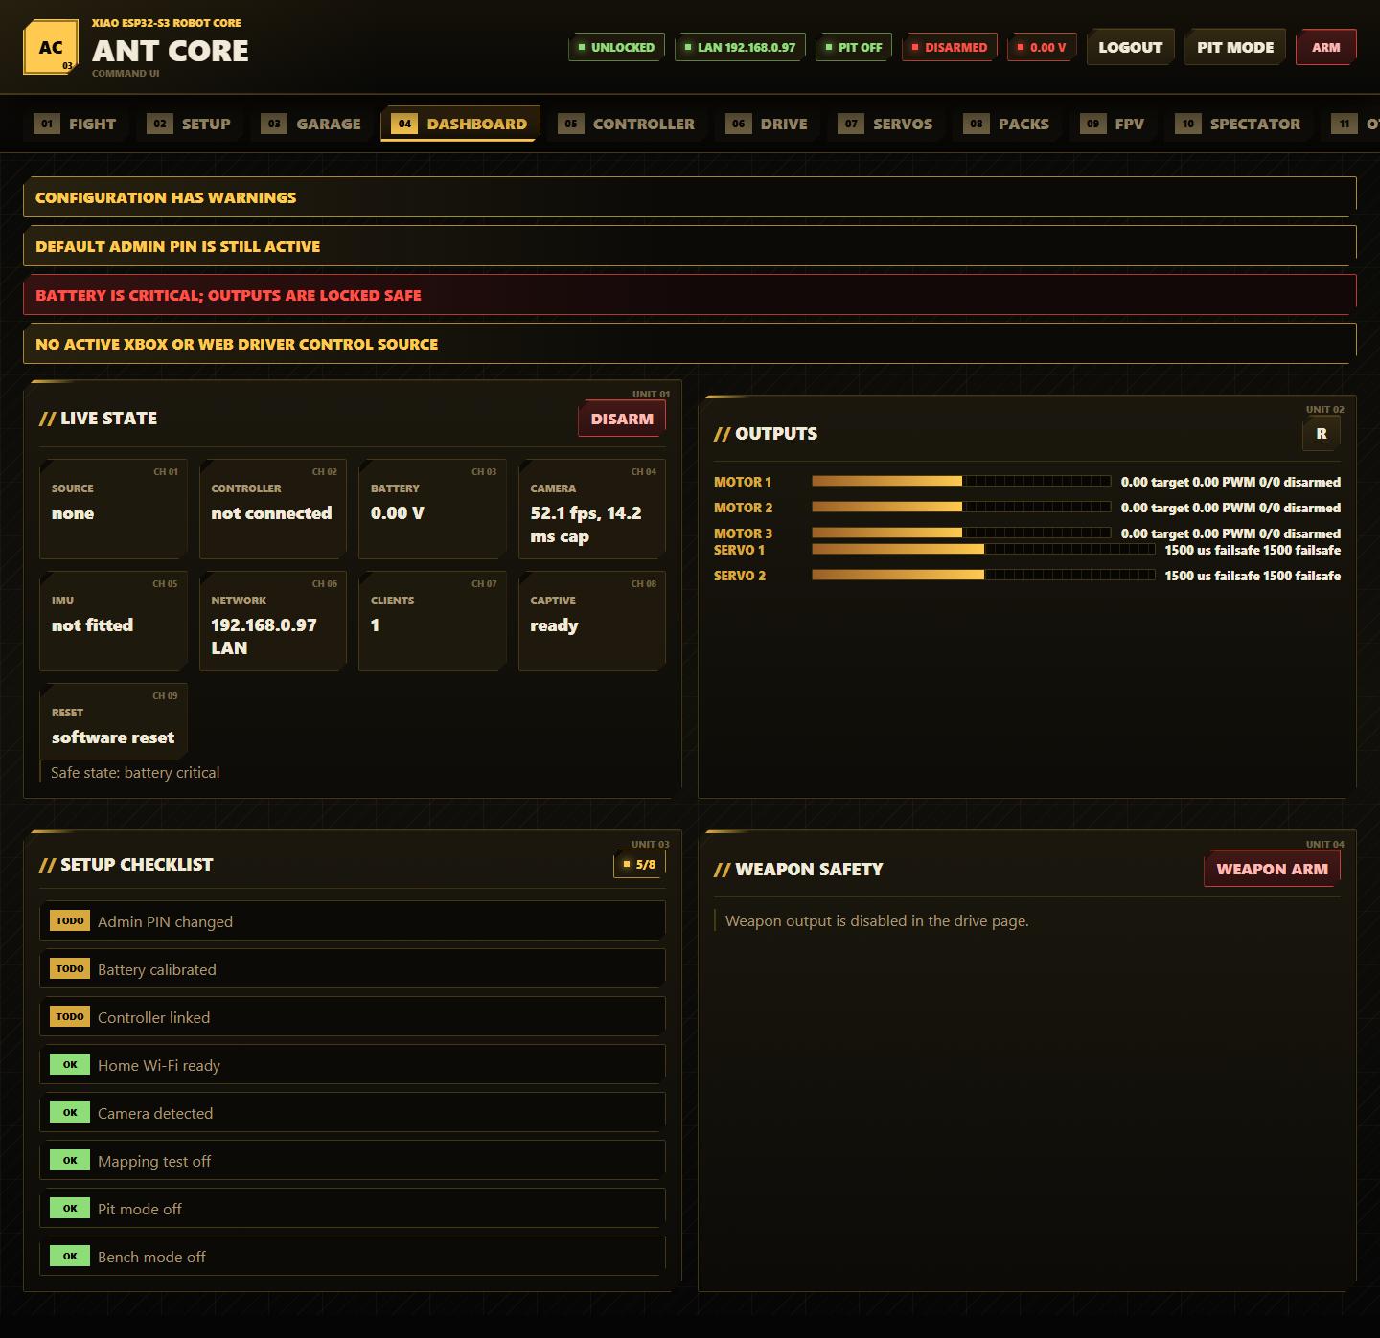

Screenshots in this README are real captures of the shipped data/index.html, data/app.css, and data/app.js web UI running with the project's mock telemetry harness. Hardware values, camera frames, and saved profiles will differ on a live board.

Table Of Contents
- Hardware (#hardware)
- Default Access (#default-access)
- Install, Build, And Upload (#install-build-and-upload)
- First Run Commissioning (#first-run-commissioning)
- Safety, Status, And Network Features (#safety-status-and-network-features)
- Web UI Feature Guide (#web-ui-feature-guide)
- Serial And Test Tools (#serial-and-test-tools)
- Validation (#validation)
- Project Layout (#project-layout)
- Troubleshooting (#troubleshooting)

Hardware
Target board:
- Seeed XIAO ESP32-S3 Sense
- Arduino framework through PlatformIO
- LittleFS web filesystem
- BLE Xbox controller support
- XIAO Sense camera used for FPV on port 81
Main Ant Core I/O:
XIAO pin | Ant Core function | Notes
D0 / D1 | Motor 1 A/B | DRV8837 drive output
D2 / D3 | Motor 2 A/B | DRV8837 drive output
D4 / D5 | I2C SDA/SCL | Optional BMI270 IMU
D6 / D7 | Servo 1 / Servo 2 | Configurable pulse limits and failsafe
D8 | 2S LiPo sense | 20k top, 10k bottom divider, default multiplier 3.0
D9 / D10 | Motor 3 A/B | Usually weapon motor output

Read the detailed wiring notes before powering hardware:
- Pinout (docs/pinout.md)
- Wiring and safety checklist (docs/wiring-and-safety.md)
- Controller setup (docs/controller-setup.md)
- Battery calibration (docs/battery-calibration.md)
- OTA and recovery (docs/ota-and-recovery.md)

Default Access
Item | Default
Access point | AntCore-XXXX
AP password | antcore123
AP setup URL | http://192.168.4.1/
mDNS URL | http://antcore.local/
Admin PIN | antcore
Serial baud | 115200

Change the admin PIN and AP password before driving near people. With authentication enabled, arming is blocked while the admin PIN is still the default.
Development Wi-Fi credentials can be kept out of source control by copying include/antcore_local_secrets.example.h to include/antcore_local_secrets.h and editing the local macros.

Install, Build, And Upload
- Install Python and PlatformIO.
- Install the project Python tools:
python -m pip install -r requirements.txt
- Build the firmware:
pio run
- Upload firmware over USB:
pio run --target upload
- Upload the LittleFS web interface:
pio run --target uploadfs
- Open the serial monitor if you want boot logs:
pio device monitor
PlatformIO normally auto-detects the XIAO ESP32-S3 serial port. If more than one board is connected, pass the port explicitly, for example:
pio run --target upload --upload-port COM7
pio run --target uploadfs --upload-port COM7

First Run Commissioning
Do this with the robot restrained, wheels clear, and the weapon made safe.
- Remove the safety link.
- Connect USB.
- Upload firmware and LittleFS web assets.
- Join the AntCore-XXXX Wi-Fi network.
- Open the captive portal, http://192.168.4.1/, or http://antcore.local/.
- Log in with the admin PIN.
- Change the admin PIN and AP password in Diagnostics -> Security.
- Check battery voltage in Diagnostics -> Battery.
- Calibrate battery voltage against a multimeter.
- Pair an Xbox controller or use FPV -> TAKE for browser control.
- Configure drive, weapon, servo, and action mappings.
- Use the Drive Direction Wizard to record left/right wheel direction.
- Use Diagnostics -> Output Test only when the robot is physically safe.
- Save a named profile.
- Export the config backup.
- Enable pit mode whenever the robot is in the pits or on the bench.
- Fit the safety link only when ready for a controlled live test.

Safety, Status, And Network Features
These features are used across multiple pages and are easy to miss if you only read one tab section.

Arming And Output Safety
- Ant Core boots disarmed and writes motor outputs low.
- Robot arming is blocked when authentication is enabled and the admin PIN is still the default.
- Robot arming is blocked by invalid config, pit mode, controller mapping test mode, OTA, USB bench mode, critical battery, or no fresh control source when that requirement is enabled.
- Runtime safety disarms the robot on pit mode, mapping test mode, bench mode, stale web control, stale Xbox input, or control link loss.
- Weapon arming is separate from robot arming. The weapon can only arm when the robot is armed and the weapon output is enabled.
- Robot disarm clears weapon output, motor targets, self-right activity, gyro heading hold, and servo toggle latches.
- Live output tests require admin login, live-output enable, robot arm, and a safe physical setup.
- Serial live output tests require LIVE_OUTPUT_ENABLE 1 or the serial bridge --live-output flag.

Admin Sessions And Secret Handling
- Press Login to create an admin session token.
- Mutating web actions send that token in the X-AntCore-Token header.
- Press Logout to clear the browser token.
- Admin PIN, AP password, and station password are write-only in the browser.
- /api/config reports whether secrets are set, but password fields come back blank.
- Leave password fields blank when saving if you want to keep the stored secret.
- Change both the admin PIN and AP password before running at an event.

Control Source Ownership
- Xbox BLE and browser FPV controls are competing driver sources.
- The browser must press TAKE on the FPV page to hold the web driver lock.
- Only the browser with the web driver lock can send drive frames.
- Multiple dashboard clients are shown as diagnostics; they do not by themselves block arming.
- Use FREE, close the page, or hide the page to release web control.
- Use Dashboard or Controller -> Live Inspector to check source, web lock, web clients, and signal health.

Config Validation
- Ant Core validates the current config after load, import, and save.
- Errors make the config invalid and block arming.
- Warnings are shown in Dashboard banners and Diagnostics -> Config Health.
- Examples of warnings include missing BMI270 for gyro features, calibration disabled, mapping test mode enabled, battery safety disabled, pit mode enabled, no fresh-control-source requirement, admin PIN protection disabled, default admin PIN, or short AP password.
- Fix validation errors before a live test.
- Treat warnings as event-prep tasks unless you intentionally enabled that behavior for bench work.

Captive Portal, AP, LAN, And mDNS
- The Ant Core access point stays available as a setup fallback.
- Captive portal DNS is enabled on the AP when possible, so phones and laptops should open the setup UI after joining AntCore-XXXX.
- If the captive portal does not open, browse to http://192.168.4.1/.
- The Setup page includes an offline QR code for the AP setup URL.
- Station mode can join a trusted Wi-Fi network for LAN debugging.
- When LAN is connected, use the shown LAN IP or http://antcore.local/ where mDNS is supported.
- Dashboard shows AP/LAN state, captive DNS state, connected clients, and reset reason.

Status LED Codes
The XIAO red power/charge LED is hardware-controlled. Firmware drives the available status LED pattern:
Pattern | Meaning
Rapid flash | Firmware is alive but still booting
Fast flash | Joining configured Wi-Fi
Solid on | Connected to configured Wi-Fi
Double pulse | AP-only or AP fallback mode
Triple pulse | Safe boot, peripheral failure, or recovery state
Very fast flash | Robot is armed and outputs may be live
Fastest flash | OTA or restart in progress; do not remove power

Visual-Only Fight Effects
- Fight Mode uses visual countdown and warning effects only.
- The project intentionally does not add sound or audio effects.
- Browser visual effects respect reduced-motion preferences where supported.

Web UI Feature Guide
The main UI has twelve tabs:
Fight, Setup, Garage, Dashboard, Controller, Drive, Servos, Packs, FPV, Spectator, OTA, and Diagnostics.

Header Controls
Every normal page shows the status header.
- Read the status badges: auth, network, pit mode, arm state, and battery.
- Press Login and enter the admin PIN before changing settings.
- Press Pit Mode to lock live outputs while configuring or waiting in the pits.
- Press ARM only after the setup checklist is clear and a fresh control source is present.
- Use any Disarm or emergency disarm button to stop outputs immediately.

Fight
Ant Core fight mode
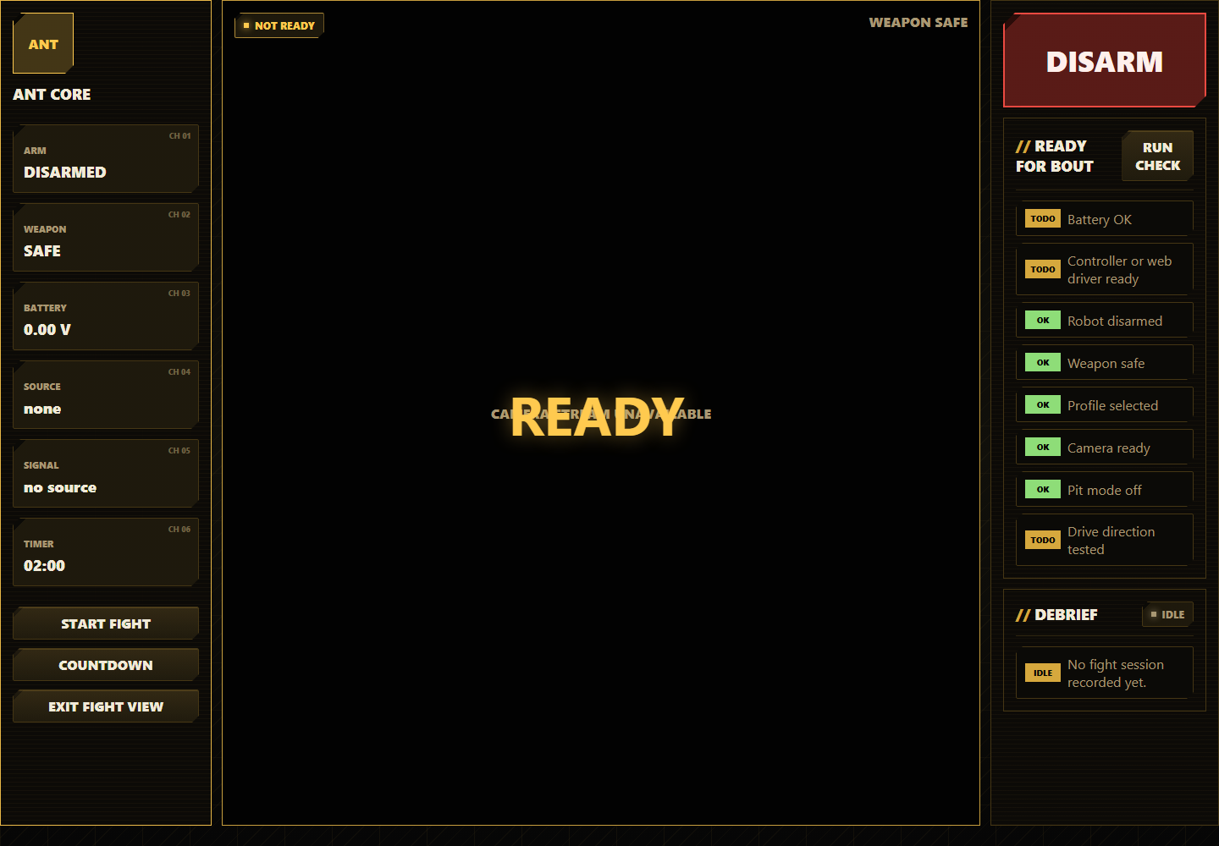

Fight Mode is the simplified bout view. It hides configuration controls and keeps the combat information visible.
- Open Fight.
- Press Run Check in Ready For Bout.
- Confirm battery, controller or web driver, pit mode, profile, camera, weapon safety, and drive direction are ready.
- Press Countdown for a visual countdown, or Start Fight to start the match timer immediately.
- Watch arm state, weapon state, battery, timer, control source, and signal health.
- Press the large DISARM button if anything behaves unexpectedly.
- Press Exit Fight View to return to the normal tabbed UI.
- Review Debrief after the fight for duration, lowest battery, disconnects, failsafes, weapon arm events, reset reason, and recent logs.

Setup
Ant Core setup wizard
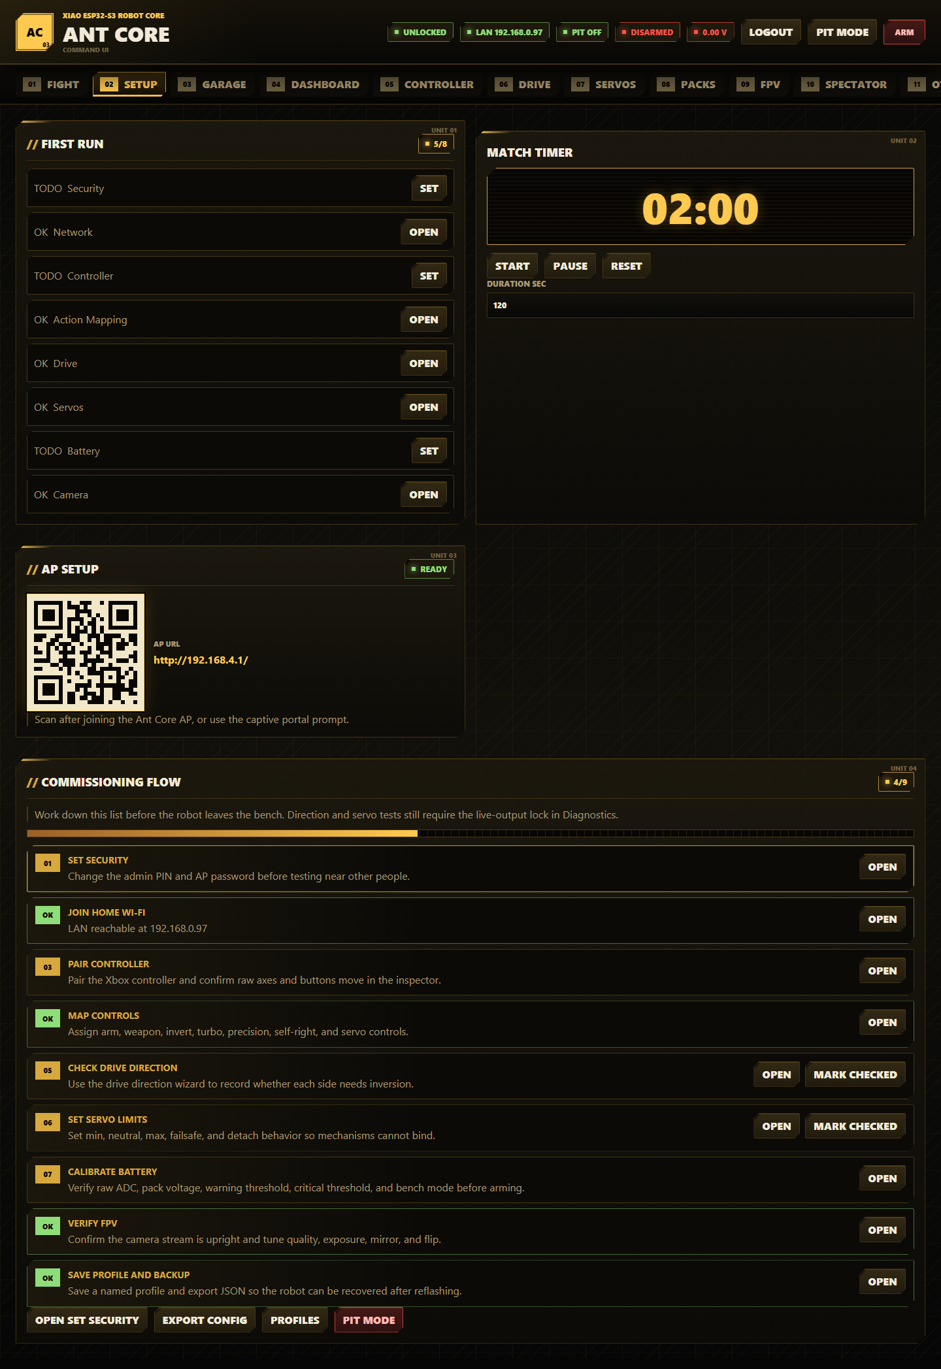

Setup is the first-run commissioning flow.
- Open Setup.
- Work through the First Run and Commissioning Flow cards from top to bottom.
- Use the progress meter to find incomplete setup items.
- Use Open Next Step to jump to the next page that needs attention.
- Use the AP QR code after joining the Ant Core AP to open http://192.168.4.1/ from a phone.
- Use the Match Timer for local bench or fight timing.
- Press Export Config after commissioning so you can restore settings after reflashing.
- Press Profiles to jump to profile management in Diagnostics.
- Press Pit Mode before bench work or event-pit handling.
Use the Match Timer:
- Enter Duration sec between the supported limits.
- Press Start to begin counting down.
- Press Pause to stop the timer without clearing the remaining time.
- Press Reset to return to the configured duration.
- The same timer value is reused by Fight Mode and Spectator display.

Garage
Ant Core garage
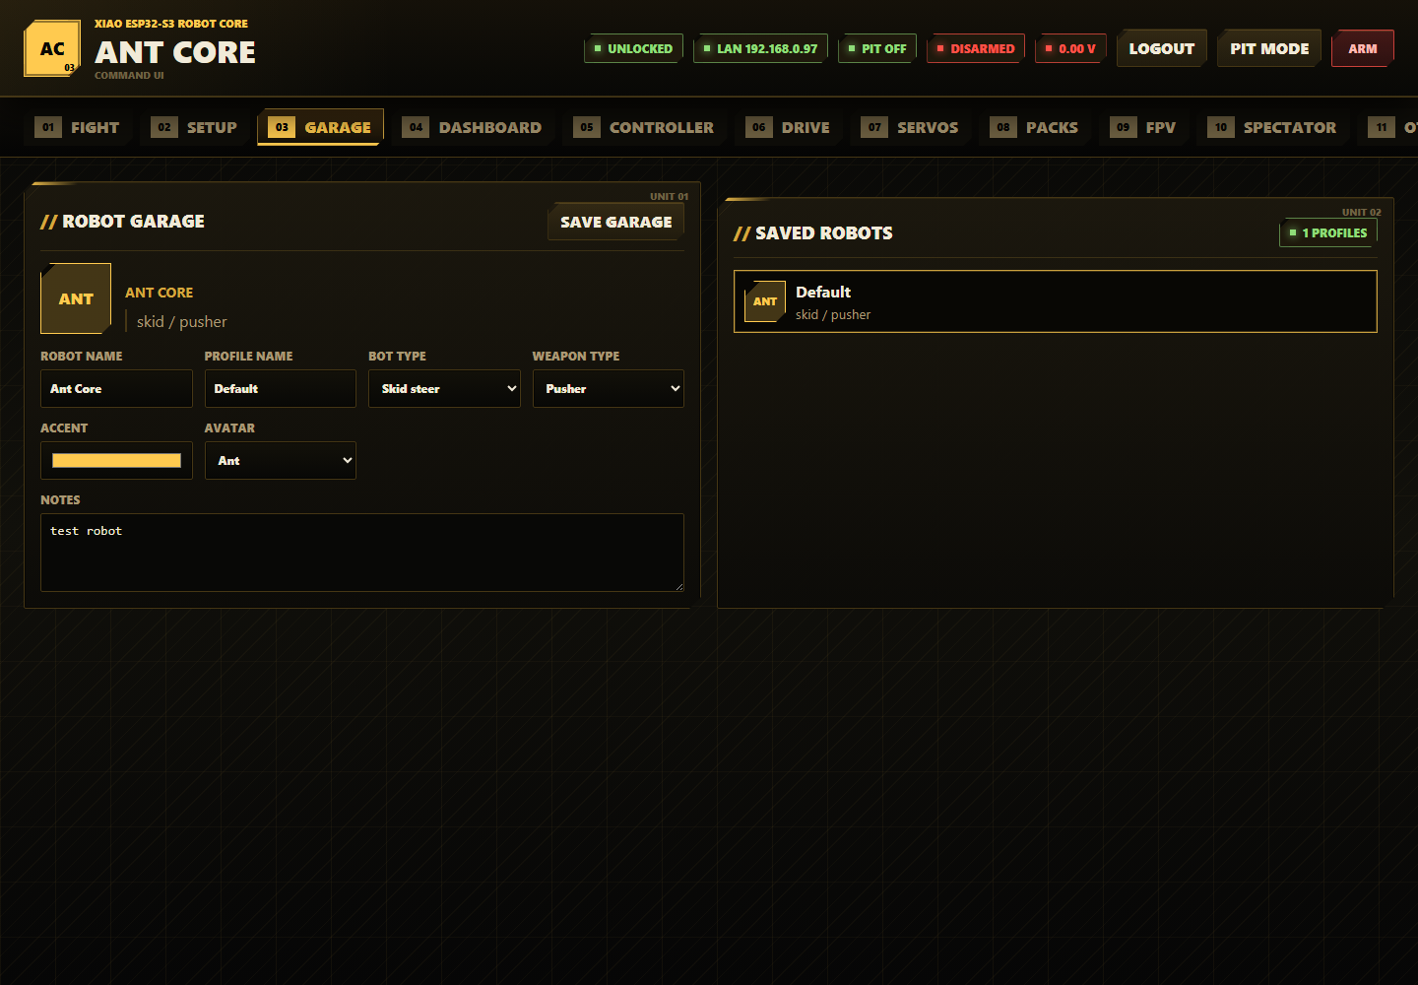

Garage stores robot metadata alongside the active config/profile.
- Open Garage.
- Enter the robot name.
- Enter the profile name.
- Choose bot type: skid steer, invertible, wedge, control bot, or experimental.
- Choose weapon type: pusher, vertical spinner, horizontal spinner, flipper, grabber, or lifter.
- Choose an accent colour and avatar.
- Add event or build notes.
- Press Save Garage.
- Use Saved Robots to select stored profile cards when profiles exist on the board.
Garage field reference:
Field | What it controls
Robot Name | Name shown on Dashboard, Fight, Spectator, and exported configs
Profile Name | Name used when saving/loading a robot setup
Bot Type | Metadata: skid steer, invertible, wedge, control bot, or experimental
Weapon Type | Metadata and preset hint: pusher, vertical spinner, horizontal spinner, flipper, grabber, or lifter
Accent | UI accent colour for robot avatar cards
Avatar | Short avatar label: ant, wedge, spinner, claw, bolt, or shield
Notes | Short build or event notes stored with the config/profile

Dashboard
Ant Core dashboard

Dashboard is the normal operating overview.
- Read safety banners first. They explain why arming is blocked.
- Check Live State for source, controller, battery, camera, IMU, network, clients, captive portal, and reset reason.
- Use Disarm to force safe output at any time.
- Review Outputs for requested output, ramped output, PWM duty, and failsafe override state for all motors and servos.
- Use Refresh if you need an immediate status poll.
- Review Setup Checklist until all items are OK.
- Use Weapon Safety to arm or safe the weapon, but only after the robot itself is armed and the weapon is enabled.

Controller
Ant Core controller page (part 1 of 3)
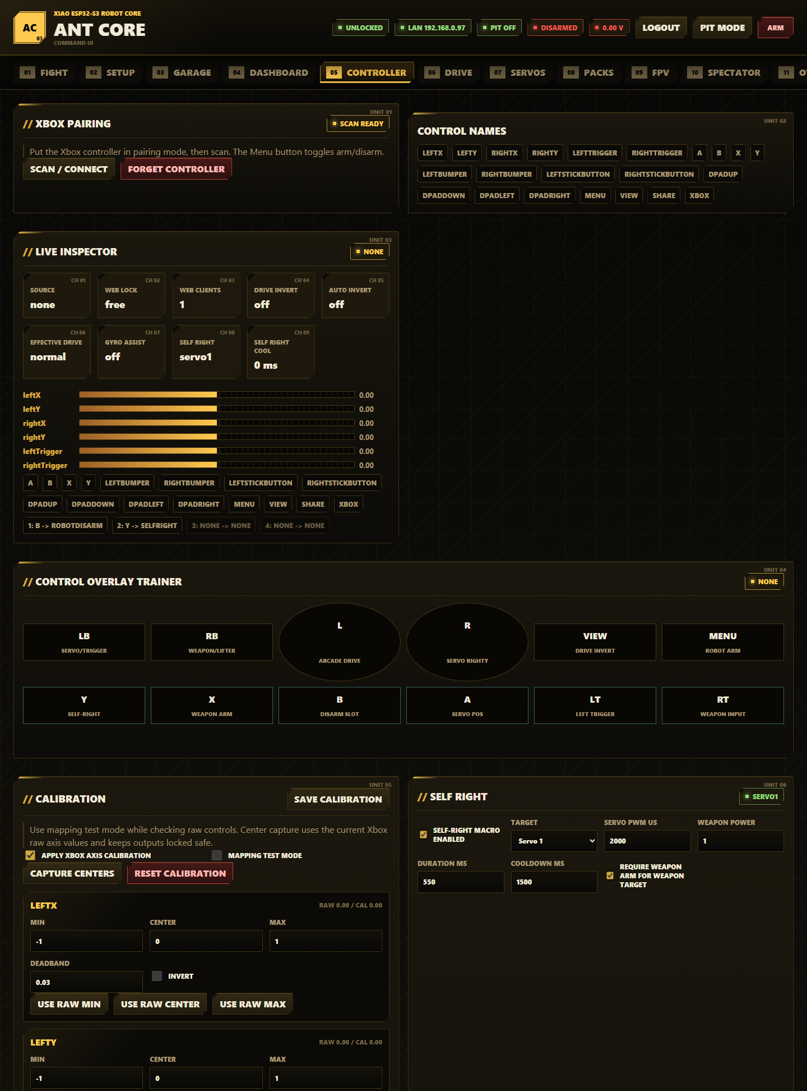

Ant Core controller page (part 2 of 3)
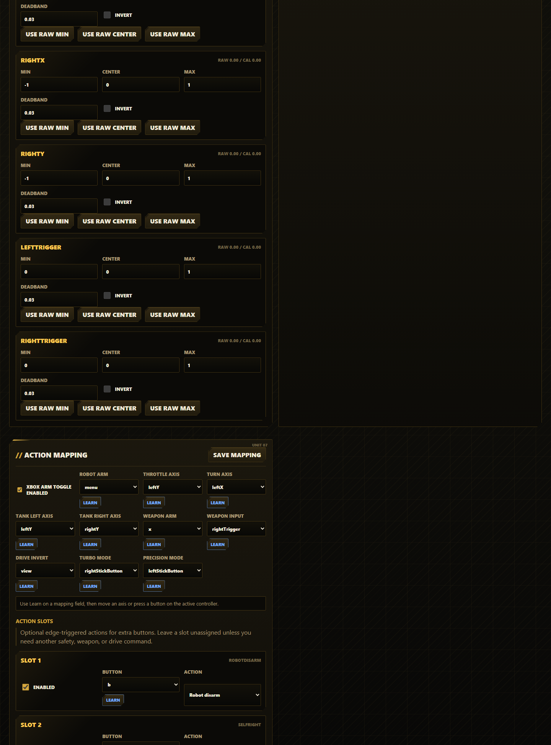

Ant Core controller page (part 3 of 3)
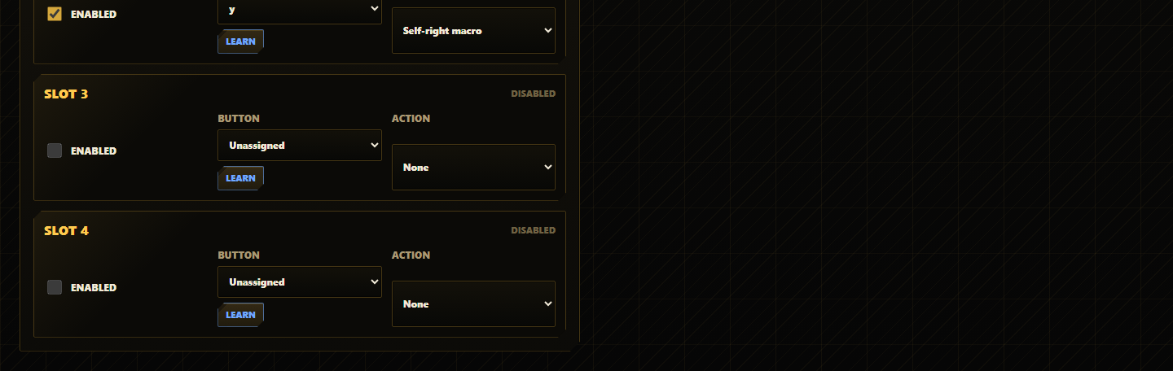

Controller manages Xbox BLE pairing, mapping, calibration, self-right, and action slots.
Pair an Xbox controller:
- Open Controller.
- Log in.
- Press Scan / Connect.
- Put the Xbox controller into pairing mode.
- Wait for Live Inspector to show live axes and buttons.
- Press Forget Controller only when you need to clear BLE bonds and pair again.
Inspect controls:
- Use Control Names to see every supported axis and button name.
- Watch Live Inspector for source, web lock, web clients, drive invert, effective invert, gyro assist, self-right target, and cooldown.
- Use Control Overlay Trainer to see which physical buttons currently map to drive, weapon, self-right, invert, turbo, precision, and servo actions.
Calibrate axes:
- Enable apply Xbox axis calibration.
- Enable mapping test mode when you want to inspect controls with arming and outputs locked safe.
- Leave sticks and triggers centered.
- Press Capture Centers.
- Move each axis to its limits and use the raw min/max buttons if needed.
- Adjust deadband and invert per axis.
- Press Save Calibration.
- Turn mapping test mode off before trying to arm.
- Press Reset Calibration only when you want to restore all axis min, center, max, deadband, and invert values to defaults.
Configure self-right:
- Enable self-right macro enabled.
- Choose target: Servo 1, Servo 2, or weapon motor.
- Set servo pulse or weapon power.
- Set duration and cooldown.
- Decide whether weapon-target self-right requires weapon arm.
- Save mapping/config.
- Assign Self-right macro to an action slot or button mapping.
Self-right field reference:
Field | What it controls
Target | Output used by the macro: Servo 1, Servo 2, or weapon motor
Servo PWM us | Pulse sent when the target is a servo
Weapon Power | Signed motor power sent when the target is the weapon motor
Duration ms | How long the macro output stays active
Cooldown ms | Minimum time before the macro can run again
require weapon arm for weapon target | Keeps weapon-target self-right behind the dedicated weapon arm state

Configure action mapping:
- Enable or disable Xbox arm toggle.
- Choose the Robot Arm button.
- Set throttle, turn, tank-left, and tank-right axes.
- Set Weapon Arm and Weapon Input.
- Set Drive Invert, Turbo Mode, and Precision Mode buttons.
- Press Learn next to a field, then move the target axis or press the target button.
- Configure Action Slots 1-4 if you need extra button-triggered actions.
- Available action-slot actions are none, robot arm toggle, robot disarm, weapon arm toggle, weapon safe, drive invert toggle, and self-right macro.
- Press Save Mapping.

Drive And Weapon
Ant Core drive and weapon page
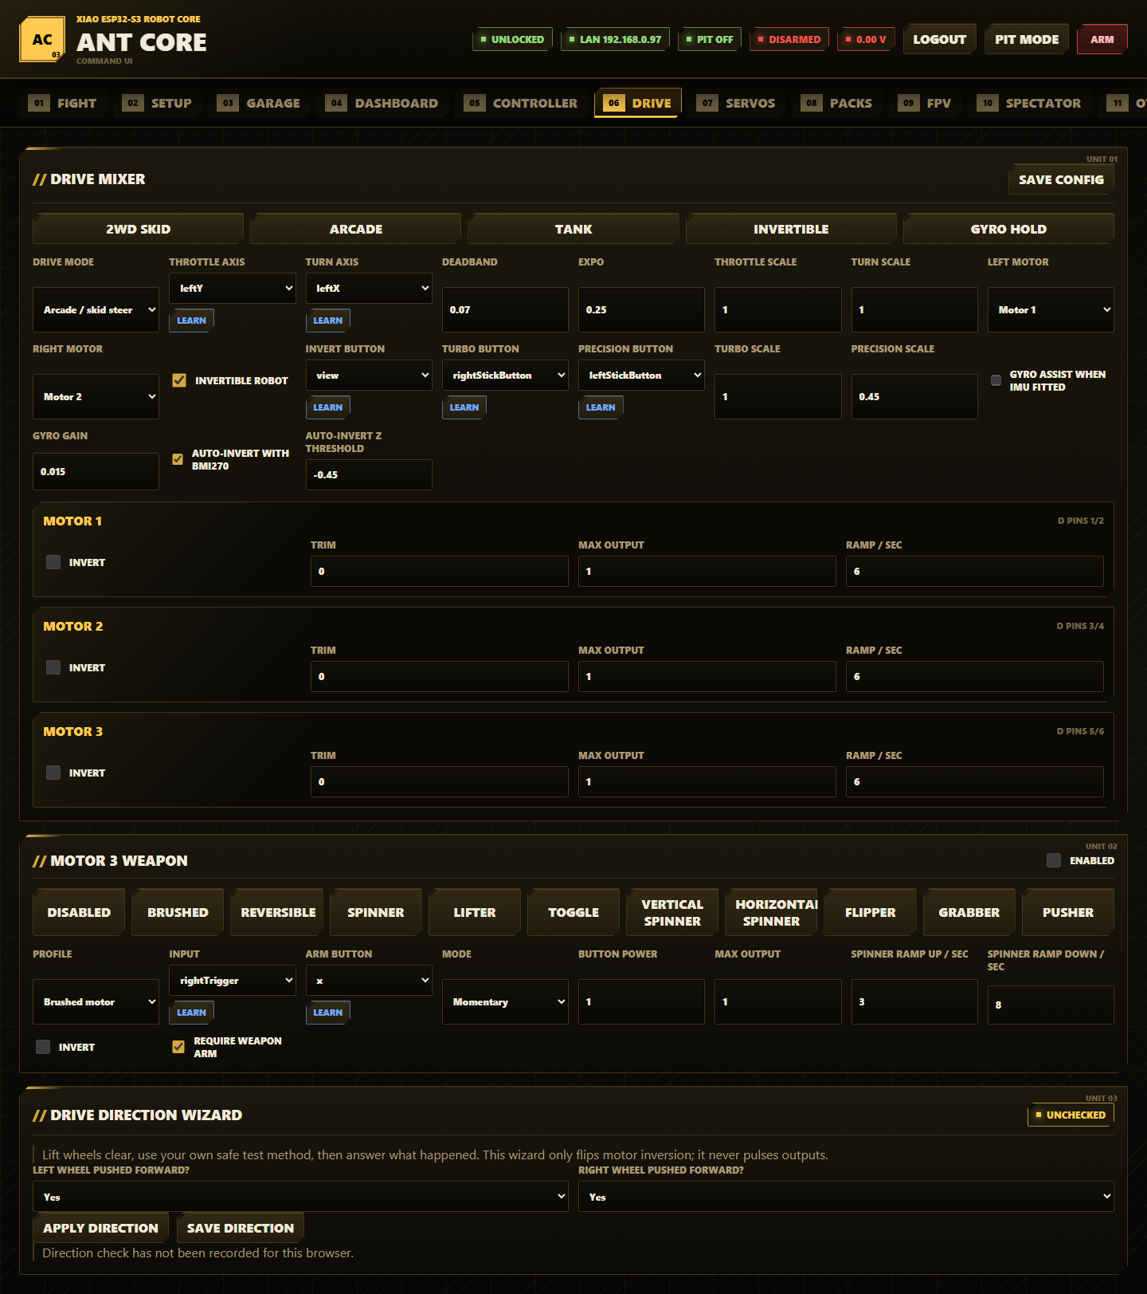

Drive configures the drive mixer, motor limits, weapon motor, and drive direction.
Use drive presets:
- Open Drive.
- Pick a preset first: 2WD Skid, Arcade, Tank, Invertible, or Gyro Hold.
- Adjust individual fields after applying the preset.
- Press Save Config.
Configure the mixer:
- Choose Drive Mode: arcade/skid steer or tank.
- Pick throttle and turn axes for arcade drive.
- Pick left and right tank axes for tank drive.
- Set deadband to ignore stick noise.
- Set expo for softer low-stick response.
- Set throttle and turn scale.
- Choose which motor drives the left side and right side.
- Enable invertible robot if the robot can run upside down.
- Choose invert, turbo, and precision buttons.
- Set turbo and precision scales.
- Enable gyro assist only when the BMI270 is fitted and mounted securely.
- Enable auto-invert with BMI270 only after confirming the board orientation.
- Tune Auto-Invert Z Threshold only if the board mounting angle needs a different upside-down detection threshold.
Drive field reference:
Field | What it controls
Drive Mode | Arcade/skid steer mixing or tank drive
Throttle Axis / Turn Axis | Main arcade drive inputs
Tank Left Axis / Tank Right Axis | Independent side inputs for tank mode
Deadband | Stick range ignored around center
Expo | Softer response near center while retaining full range
Throttle Scale / Turn Scale | Maximum normal throttle and turn authority
Left Motor / Right Motor | Motor outputs assigned to each drive side
Invert Button | Button used to flip driver direction manually
Turbo Button / Precision Button | Buttons used to change drive scaling while held or active
Turbo Scale / Precision Scale | Output scale for the turbo and precision modes
Gyro Gain | Heading-hold correction strength when gyro assist is active

Configure motor outputs:
- Review Motor 1, Motor 2, and Motor 3 rows.
- Use invert to correct direction in firmware instead of rewiring.
- Use trim for small left/right bias correction.
- Use max output to cap power.
- Use ramp rate to soften acceleration.
- Save config.
Configure Motor 3 weapon:
- Choose a weapon preset: Disabled, Brushed, Reversible, Spinner, Lifter, Toggle, Vertical Spinner, Horizontal Spinner, Flipper, Grabber, or Pusher.
- Enable the weapon only if Motor 3 is wired to a safe weapon output.
- Choose profile: brushed motor, spinner, lifter/flipper, or reversible weapon.
- Choose input and arm button.
- Choose momentary or toggle mode.
- Set button power and max output.
- Set spinner ramp-up and ramp-down rates for high-inertia weapons.
- Set invert if the weapon direction is wrong.
- Keep require weapon arm enabled for event use.
- Save config.
Weapon mode reference:
Field | What it controls
Profile | Brushed motor, spinner, lifter/flipper, or reversible weapon behavior
Input | Axis or button that commands weapon output
Arm Button | Dedicated button used to toggle weapon arm state
Mode | Momentary or toggle command behavior
Button Power | Output used for button-style weapon input
Max Output | Absolute cap on weapon output
Spinner Ramp Up / sec | Acceleration limit for spinner-style outputs
Spinner Ramp Down / sec | Deceleration limit for spinner-style outputs
invert | Reverses weapon motor direction
require weapon arm | Requires the separate weapon arm state before output can run

Use the Drive Direction Wizard:
- Lift the wheels clear.
- Use your own safe low-power test method to observe wheel direction.
- For each side, answer whether the wheel was pushed forward.
- Press Apply Direction to flip inversion locally.
- Press Save Direction to persist it.
- The wizard only updates inversion settings; it does not pulse motors itself.

Servos
Ant Core servos page
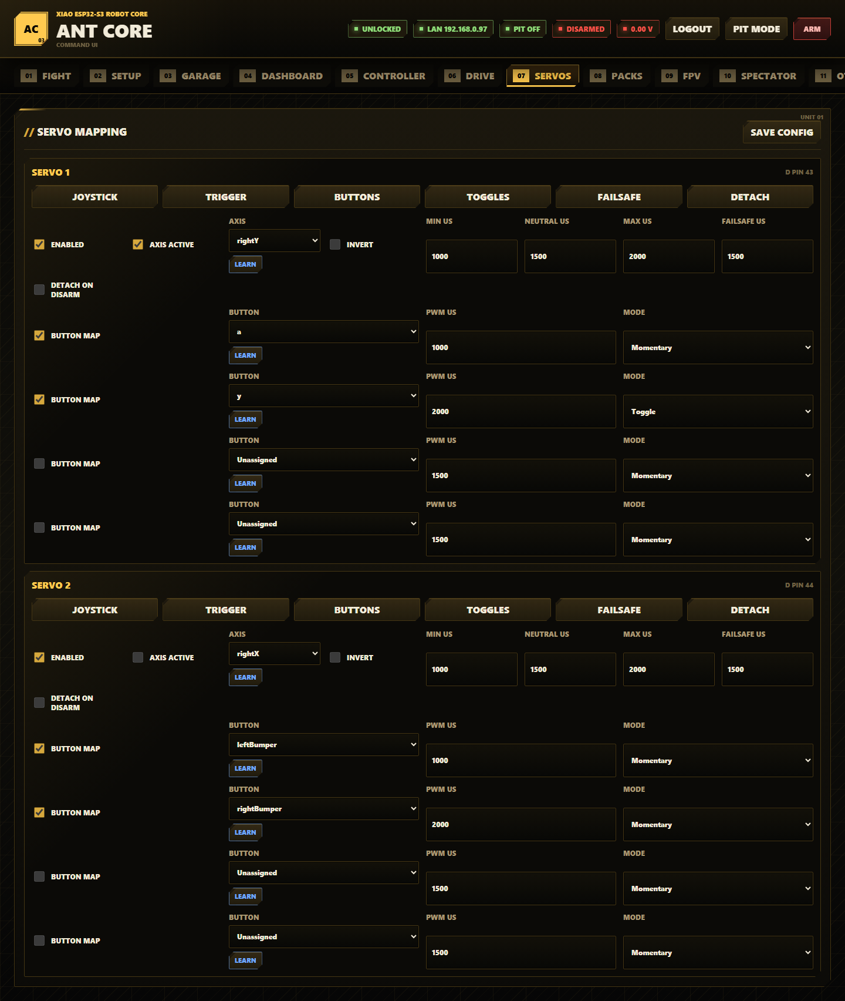

Servos configures Servo 1 and Servo 2 control, limits, button positions, and failsafe behavior.
- Open Servos.
- Pick a servo preset: joystick proportional, trigger proportional, button positions, toggle positions, failsafe hold, or detach on disarm.
- Enable the servo only after pulse limits are safe.
- Choose axis mode if you want proportional control.
- Select the axis and invert if required.
- Set min, neutral, max, and failsafe pulse widths.
- Enable detach-on-disarm only when the mechanism is safe without holding torque.
- Configure button positions for momentary or toggle-latched servo commands.
- Keep toggle positions for deliberate latch use only; robot disarm clears toggle latches back to safe behavior.
- Press Save Config.
- Test travel from Diagnostics -> Output Test with linkages disconnected first.

Packs
Ant Core battery packs page
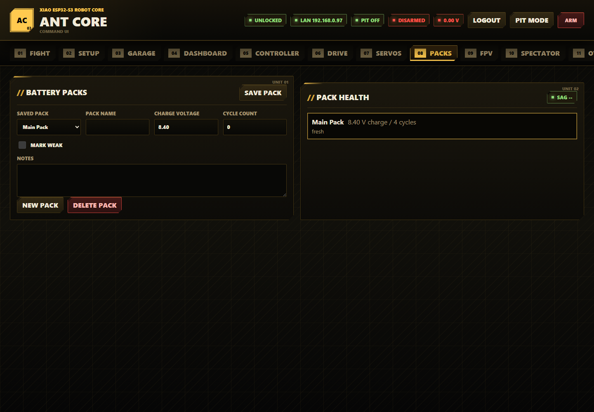

Packs stores battery pack notes on the board.
- Open Packs.
- Press New Pack or select an existing pack.
- Enter pack name.
- Enter charge voltage.
- Enter cycle count.
- Mark weak packs when they sag or should not be used for hard fights.
- Add notes.
- Press Save Pack.
- Read Pack Health for the saved pack list and live sag calculation.
- Press Delete Pack only for the selected pack you no longer need.
Pack field reference:
Field | What it controls
Saved Pack | Pack selected for editing
Pack Name | Human-readable pack name
Charge Voltage | Voltage the UI uses as the full-charge baseline
Cycle Count | Manual cycle tracking field
mark weak | Flags packs that sag or should be avoided for hard use
Notes | Short condition or event notes

FPV
Ant Core FPV controls
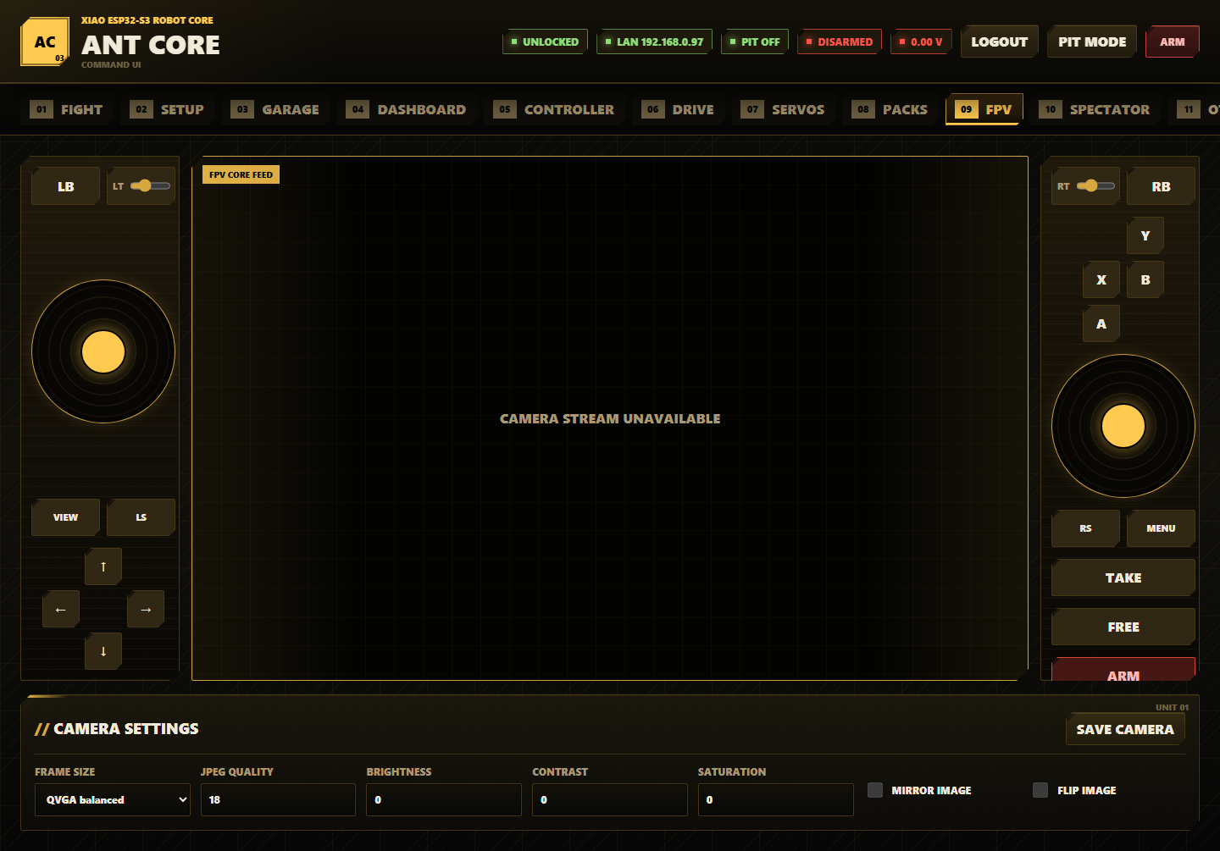

FPV combines the camera stream with a browser virtual gamepad.
Take web control:
- Open FPV.
- Log in.
- Press TAKE to claim the web driver lock.
- Use the left and right virtual sticks, bumpers, face buttons, D-pad, View/Menu, stick-click buttons, and trigger sliders.
- Press ARM only after the same safety checks you would use for Xbox control.
- Press FREE to release web control.
- Leaving or hiding the page releases web control shortly after.
Use camera settings:
- Choose frame size: QQVGA low latency, QVGA balanced, or VGA detail.
- Set JPEG quality.
- Adjust brightness, contrast, and saturation.
- Enable mirror or flip if the camera is mounted differently.
- Press Save Camera.
Control freshness:
- Browser frames older than 250 ms command neutral output.
- A missing web driver heartbeat for 750 ms forces disarm.
- Only the browser holding the web driver lock can drive.

Spectator
Ant Core spectator page
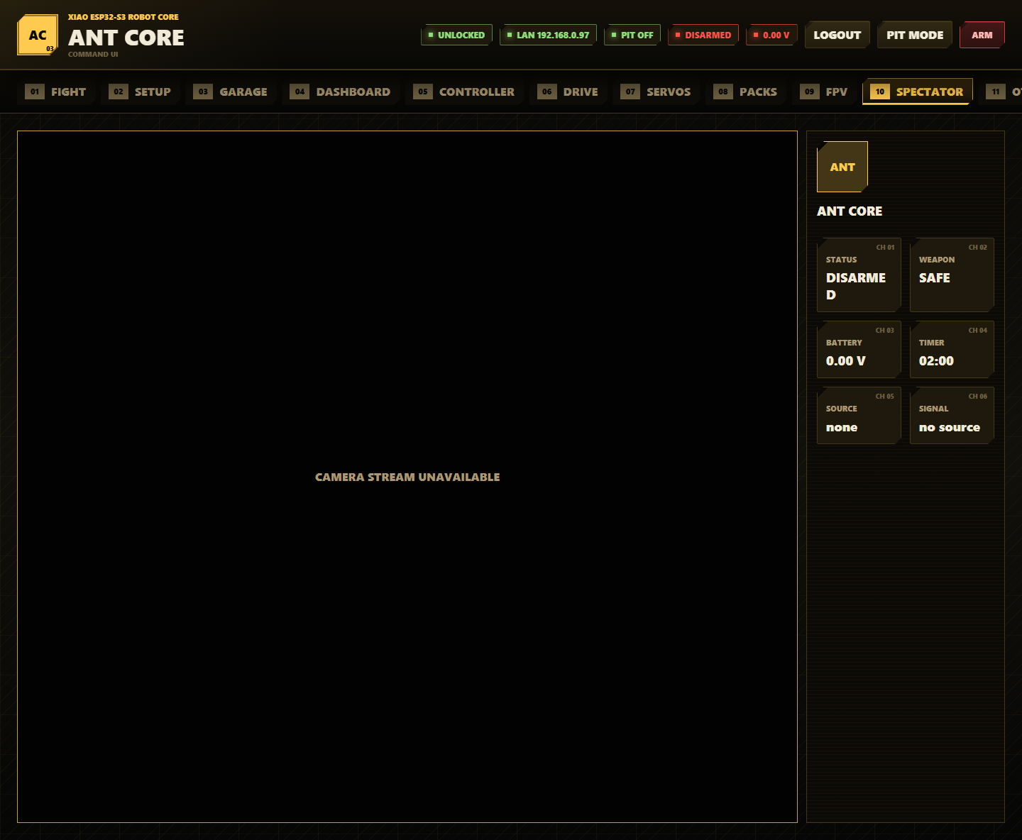

Spectator is a read-only pit or audience display.
- Open Spectator from a phone, tablet, or laptop.
- View robot avatar, name, FPV, timer, arm state, weapon state, battery, source, and signal health.
- Do not expect arm, drive, or configuration controls on this page.
- Use it for event display or pits where read-only visibility is useful.

OTA
Ant Core OTA page
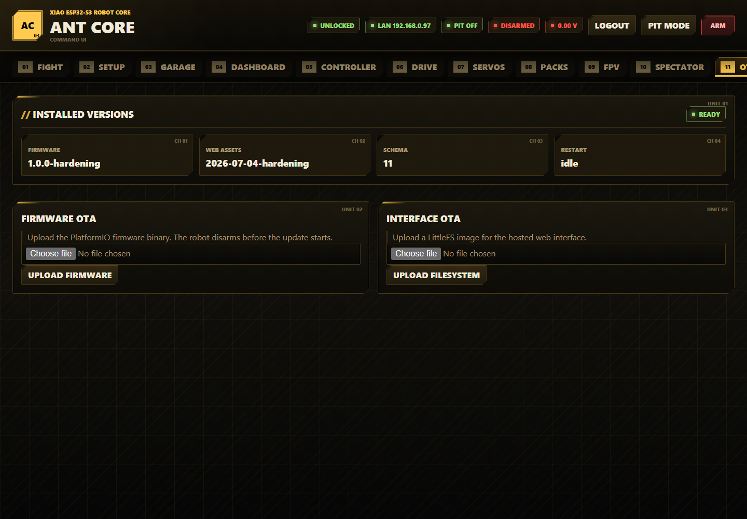

OTA updates firmware or web assets without opening the robot.
Installed Versions:
- Read Firmware before uploading a new firmware binary.
- Read Web Assets before uploading a new LittleFS image.
- Read Schema to confirm the config schema expected by the running firmware.
- Read Restart to see whether an update or config action has a pending reboot/restart state.
Before OTA:
- Remove the weapon belt or otherwise make the weapon safe.
- Put the robot on a stand.
- Confirm the battery is not near critical.
- Log in.
- Keep the browser open until upload finishes.
Firmware OTA:
- Build firmware:
pio run
- Open OTA.
- Choose .pio/build/seeed_xiao_esp32s3/firmware.bin.
- Press Upload Firmware.
- Wait for success and reboot.
- Reconnect through antcore.local, the LAN IP, or the AP.
Filesystem OTA:
- Build LittleFS:
pio run --target buildfs
- Open OTA.
- Choose .pio/build/seeed_xiao_esp32s3/littlefs.bin.
- Press Upload Filesystem in the Interface OTA card.
- Wait for reboot.
- Hard-refresh the browser if assets look stale.
Upload firmware and filesystem as separate operations.

Diagnostics
Ant Core diagnostics page
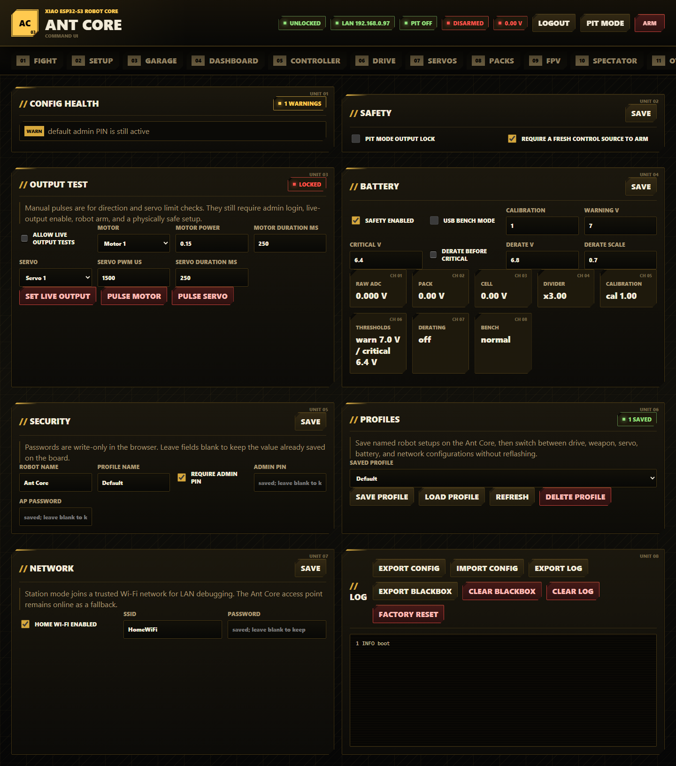

Diagnostics contains safety settings, live output tests, battery calibration, security, profiles, network settings, logs, blackbox export, config import/export, and factory reset.
Config Health:
- Open Diagnostics.
- Read Config Health before arming.
- Fix errors before attempting live operation.
- Treat warnings as setup items to resolve before event use.
Safety:
- Enable pit mode output lock while working in the pits.
- Keep require a fresh control source to arm enabled for normal use.
- Press Save.
Output Test:
- Make the robot physically safe: wheels clear, weapon disabled, linkages safe.
- Log in.
- Arm only when safe.
- Enable allow live output tests.
- Press Set Live Output.
- Choose Motor, Motor Power, and Motor Duration ms.
- Press Pulse Motor only after confirming the prompt.
- Choose Servo, Servo PWM us, and Servo Duration ms.
- Press Pulse Servo only after confirming the prompt.
- Disable live output tests when finished.
- Turn pit mode back on for bench work.
Battery:
- Enable battery safety for event use.
- Enable USB bench mode only when no LiPo is fitted and outputs are safe.
- Measure pack voltage with a trusted multimeter.
- Compare it to the displayed pack voltage.
- Calculate new calibration:
new calibration = old calibration * measured voltage / displayed voltage
- Enter calibration.
- Set warning, derate, and critical thresholds.
- Enable derating if you want output scaling before critical disarm.
- Press Save.
Battery field and readout reference:
Field or readout | Meaning
safety enabled | Enables low-voltage warning, derating, critical arming block, and critical disarm
USB bench mode | Blocks arming for USB-only setup without a LiPo
Calibration | Multiplier correction after comparing with a multimeter
Warning V | Voltage where warnings and logs begin
Critical V | Voltage where arming is blocked and the robot disarms
derate before critical | Enables output scaling before the critical threshold
Derate V | Voltage where derating begins
Derate Scale | Output scale applied while derating
Raw ADC | Voltage seen by the ADC pin before divider math
Pack / Cell | Calculated pack and per-cell voltage
Divider | Fixed divider multiplier, normally x3.00
Thresholds | Current warning and critical thresholds
Derating / Bench | Current derating and bench-mode state

Security:
- Set Robot Name and Profile Name.
- Leave require admin PIN enabled for normal use.
- Enter a non-default admin PIN.
- Enter a non-default AP password.
- Leave password fields blank to keep already saved values.
- Press Save.
Profiles:
- Enter the desired active profile name in Security or Garage.
- Press Save Profile to store the current board config.
- Choose a profile from Saved Profile.
- Press Load Profile to switch setups; loading disarms the robot.
- Press Refresh to reload the profile list.
- Press Delete Profile only for a profile you no longer need.
Network:
- Enable home Wi-Fi for LAN debugging.
- Enter SSID and Password.
- Press Save.
- Reconnect through the LAN IP or http://antcore.local/ when station mode joins successfully.
- The Ant Core AP remains available as fallback.
Logs, blackbox, and config files:
- Press Export Config after setup or before factory reset.
- Press Import Config and select a JSON backup to restore settings.
- Press Export Log for the current browser-visible diagnostic log.
- Press Export Blackbox for the persistent LittleFS blackbox log.
- Press Clear Blackbox only after exporting data you need.
- Press Clear Log to clear the diagnostic log.
- Press Factory Reset to restore defaults; this disarms the robot and requires commissioning again.

Serial And Test Tools
Install requirements first:
python -m pip install -r requirements.txt

Serial Bridge
Ant Core serial bridge
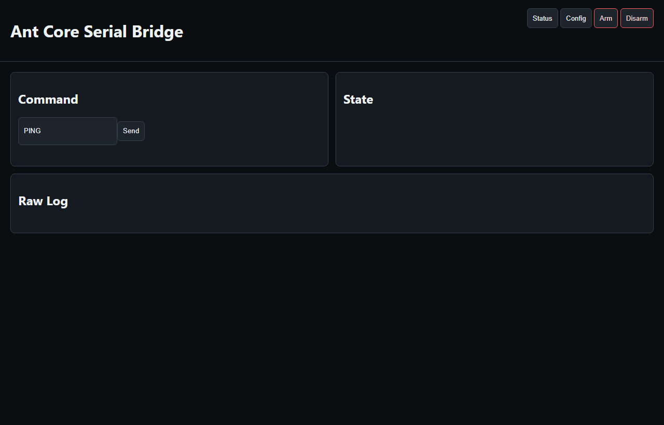

Use the serial bridge for command-line status, smoke tests, and a local serial dashboard.
python tools/antcore_serial_bridge.py --smoke
python tools/antcore_serial_bridge.py --serve
If multiple serial devices are connected:
python tools/antcore_serial_bridge.py --port COM7 --smoke
Live output smoke tests are intentionally separate:
python tools/antcore_serial_bridge.py --smoke --live-output
Only use --live-output when the robot is physically safe.
Supported serial commands:
PING
HELP
STATUS
CONFIG?
ARM
DISARM
WEAPON_ARM
WEAPON_DISARM
PIT_MODE <0|1>
BLE_SCAN
BLE_FORGET
WIFI_RECONNECT
RESET_CONFIG
LIVE_OUTPUT_ENABLE <0|1>
MOTOR_TEST <1-3> <-1..1> <ms>
SERVO_TEST <1-2> <us> <ms>

UI Audit
Run the mock browser audit:
python tools/antcore_ui_audit.py
Run a layout audit against a live board:
python tools/antcore_ui_audit.py --url http://192.168.4.1/
The audit verifies dashboard rendering, button flows, setup QR rendering, profiles, packs, presets, virtual controls, and FPV layout.

FPV Latency
Measure HTTP status, snapshot, and stream responsiveness:
python tools/measure_fpv_latency.py --host 192.168.4.1

Hardware Rig Vision Test
The rig tester can discover the board, calibrate orange tape ROIs, generate reports, and optionally run guarded physical motion checks.
Dry run without hardware:
python tools/antcore_rig_vision_test.py all --dry-run
Discover board:
python tools/antcore_rig_vision_test.py discover
Calibrate camera ROIs:
python tools/antcore_rig_vision_test.py calibrate --camera-index auto --auto-roi
Run guarded validation:
python tools/antcore_rig_vision_test.py run
Live physical movement requires --live-output and a typed confirmation. The tool does not bypass firmware battery, pit mode, mapping, or arming safety.

Mock Controller
Ant Core mock controller
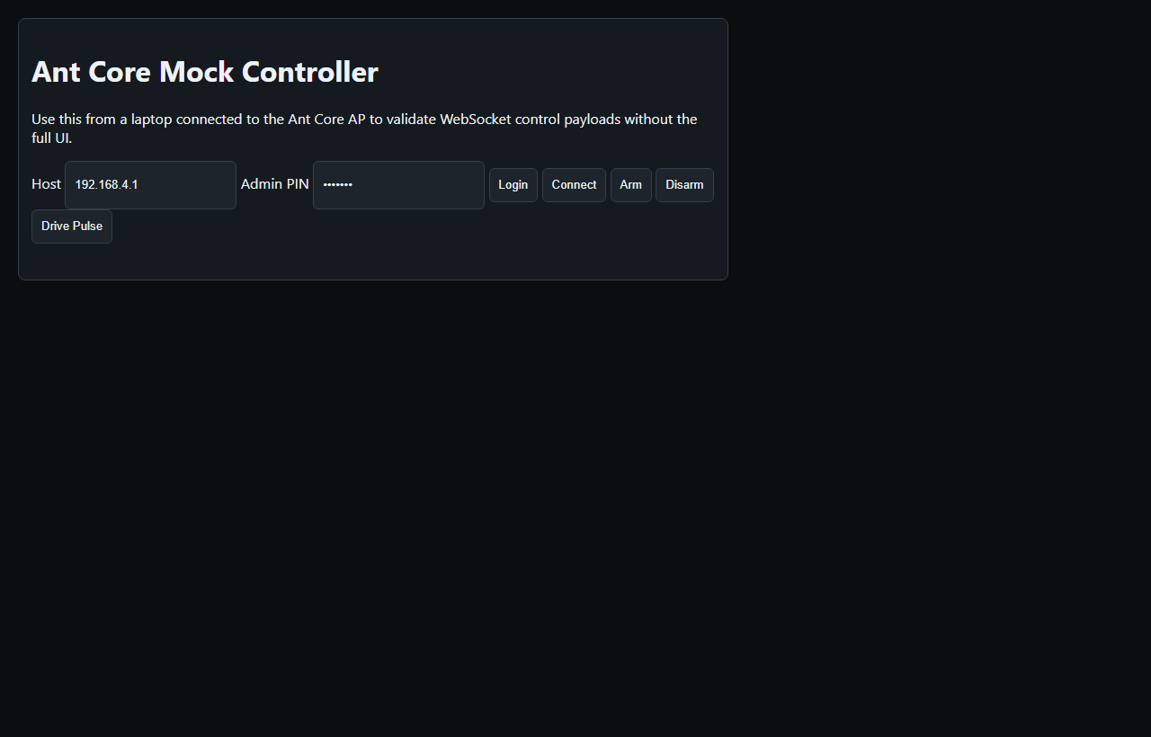

tools/antcore_mock_controller.html is a small WebSocket control test page. Open it in a browser connected to the Ant Core AP, enter the host and admin PIN, connect, claim control, and send a short drive pulse only when the robot is physically safe.

Validation
Recommended local validation:
python -m pytest
pio test -e native -f test_antcore_logic_native
python tools/antcore_ui_audit.py
python tools/antcore_serial_bridge.py --smoke
python tools/run_checks.py
Full repeatable checks:
python tools/run_checks.py
tools/run_checks.py runs firmware build, boot-probe build, LittleFS build, native tests, Python tests, and the mock UI audit unless skipped with command-line flags.

Project Layout
Path | Purpose
data/ | Web UI served from LittleFS
docs/ | Hardware, setup, and recovery documentation
docs/screenshots/ | README UI screenshots
include/antcore_firmware_config.h | Persisted config, telemetry, and controller structs
include/antcore_board.h | XIAO pin assignments and PWM channel mapping
src/main.cpp | Arduino runtime, web routes, BLE, persistence, serial command execution
src/antcore_config.cpp | Defaults, JSON import/export, redaction, validation
src/antcore_auth.cpp | Admin PIN sessions, tokens, lockout-aware auth failures
src/antcore_ble_input.cpp | BLE Xbox input translation
src/antcore_controls.cpp | Control names, button/axis readers, calibration helpers
src/antcore_sensors.cpp | Battery ADC and BMI270 sampling
src/antcore_outputs.cpp | Motor PWM and servo output helpers
src/antcore_output_test.cpp | Live output test safety gates and pulse queues
src/antcore_profiles.cpp | Named profile save/load/delete
src/antcore_packs.cpp | Battery pack note storage
src/antcore_safety.cpp | Arming and runtime safety decisions
src/antcore_serial.cpp | Serial command parser and help text
src/antcore_blackbox.cpp | Persistent blackbox logging
src/antcore_network.cpp | Captive portal redirects and camera URL helpers
src/antcore_logic.cpp | Drive mixing, battery thresholds, macros, auto-invert, interlocks
src/camera_stream.cpp | Camera initialization, MJPEG stream, snapshot server
test/ | Python and PlatformIO native tests
tools/ | UI audit, serial bridge, FPV latency, and rig validation tools

Troubleshooting
Cannot open the setup page:
- Join the AntCore-XXXX AP.
- Browse to http://192.168.4.1/.
- Try http://antcore.local/ when on the same LAN.
- Re-upload LittleFS with pio run --target uploadfs.
Arming is blocked:
- Read the Dashboard safety banner or safety.armBlockReason from /api/status.
- Change the default admin PIN.
- Turn off pit mode.
- Turn off mapping test mode.
- Connect a fresh Xbox or web control source.
- Fix battery critical or enable bench mode only for safe USB-only work.
- Resolve config validation errors.
- Wait for OTA to finish.
Controller will not pair:
- Update the Xbox controller firmware.
- Open Controller and press Forget Controller.
- Press Scan / Connect.
- Put the controller in pairing mode.
- Keep the robot near the controller during pairing.
Battery reads 0.00 V:
- Check that a LiPo is fitted.
- Check the 20k/10k divider and common ground.
- Check the D8 sense wiring.
- Use USB bench mode only for safe setup without a LiPo.
Camera stream unavailable:
- Confirm the XIAO ESP32-S3 Sense camera is fitted.
- Reboot the board.
- Check /api/status camera fields.
- Try lower frame size or higher JPEG compression from FPV -> Camera Settings.
Web assets look stale after OTA:
- Upload filesystem separately from firmware.
- Wait for reboot.
- Hard-refresh the browser.
- Clear browser cache if required.
After a fault or unexpected reset:
- Open Dashboard and note Reset reason.
- Open Diagnostics.
- Export Log.
- Export Blackbox.
- Save the report before clearing logs or resetting config.

